**UNEARTHING THE ENVIRONMENTAL IMPACT OF HUMAN ACTIVITY ; A GLOBAL CO2 EMISSION ANALYSIS**

**1.INTRODUCTION**

Carbon dioxide (CO2) is a colourless, odourless and non-poisonous gas formed by combustion of carbon and in the respiration of living organisms and is considered a greenhouse gas. Emissions means the release of greenhouse gases and/or their precursors into the atmosphere over a specified area and period of time. Carbon dioxide emissions or CO2 emissions are emissions stemming from the burning of fossil fuels and the manufacture of cement; they include carbon dioxide produced during consumption of solid, liquid, and gas fuels as well as gas flaring.

Carbon dioxide (CO2) is released into Earth’s atmosphere mostly by the burning of carbon-containing fuels and the decay of wood and other plant matter. Under all conditions found naturally on Earth, CO2 is an invisible, odorless gas. It is removed from the atmosphere mostly by plants, which extract carbon from CO2 to build their tissues, and by the oceans, in which CO2 dissolves.Because CO2 is opaque to infrared radiation (the electromagnetic waves emitted by warm objects) in the atmosphere, it acts as a blanket to slow the loss of heat from Earth into space. Although other gases are also causing Earth’s climate to warm, CO2 alone is responsible for about three-fourths of global warming.

PURPOSE

The carbon in CO2 can be used to produce fuels that are in use today, including methane, methanol, gasoline and aviation fuels.

Carbon dioxide is used as a refrigerant, in fire extinguishers, for inflating life rafts and life jackets, blasting coal, foaming rubber and plastics, promoting the growth of plants in greenhouses, immobilizing animals before slaughter, and in carbonated beverage.

Globally, some 230 million tonnes (Mt) of carbon dioxide (CO2) are used every year. The largest consumer is the fertiliser industry, where 130 Mt CO2 is used in urea manufacturing, followed by oil and gas, with a consumption of 70 to 80 Mt CO2 for enhanced oil recovery.

**2.PROBLEM DEFINITION & DESIGN THINKING**

*EMPATHY MAP

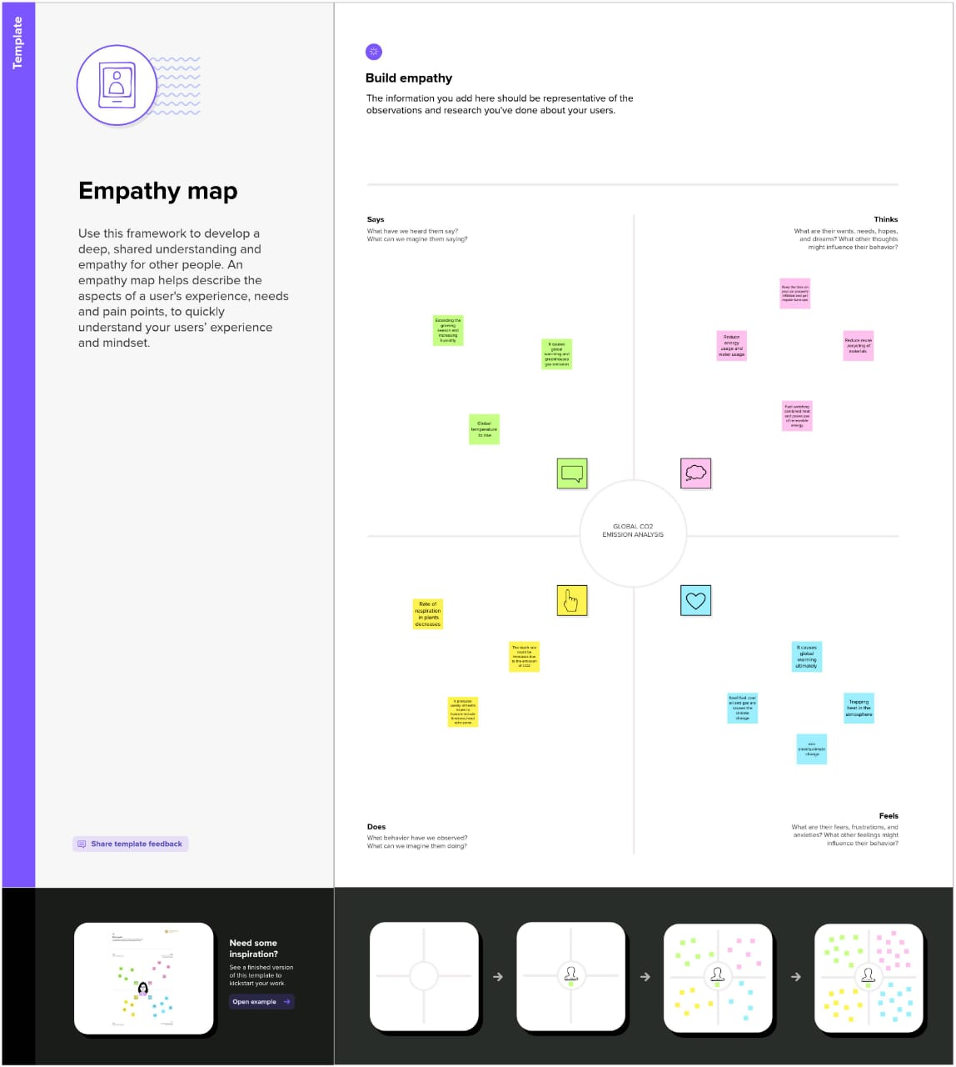

*BRAINSTORM &IDEATION

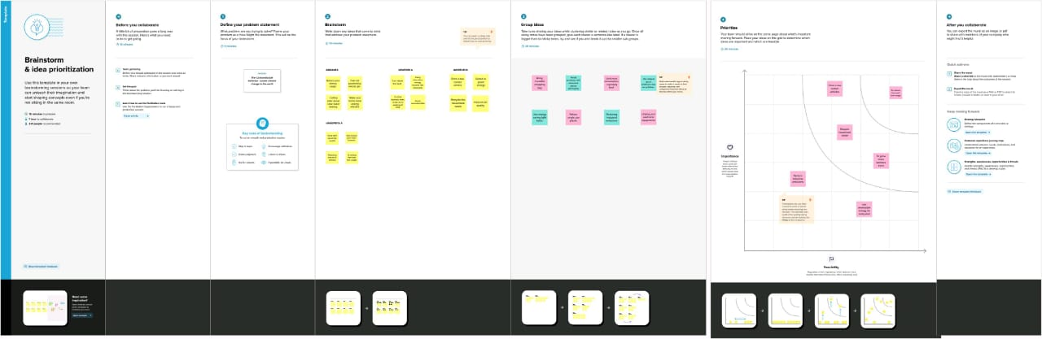

**3. RESULT**

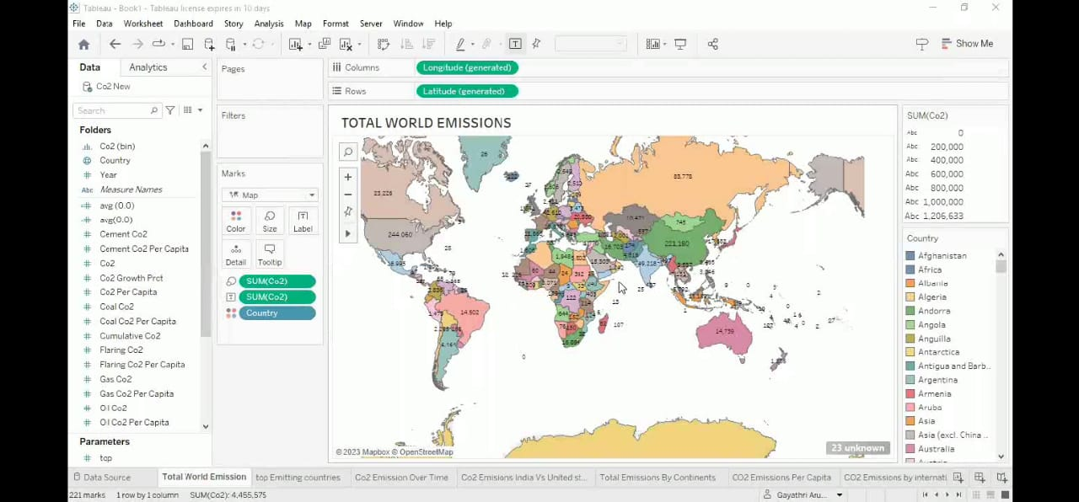

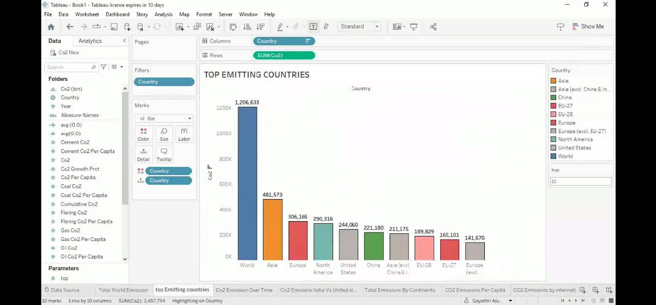

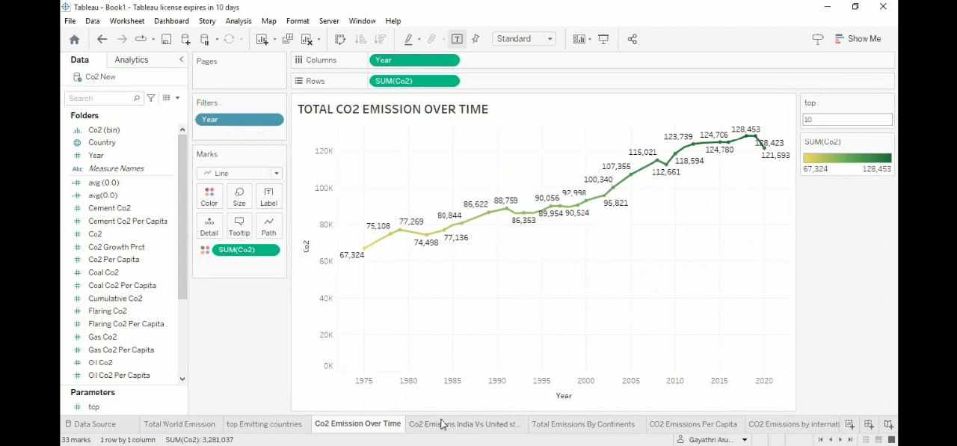

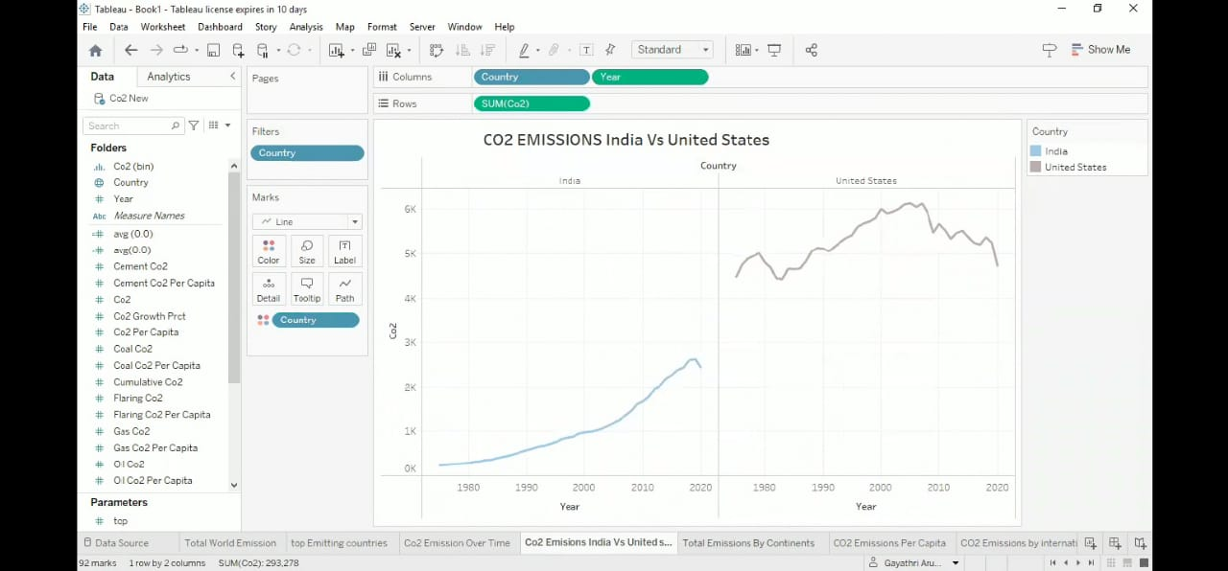

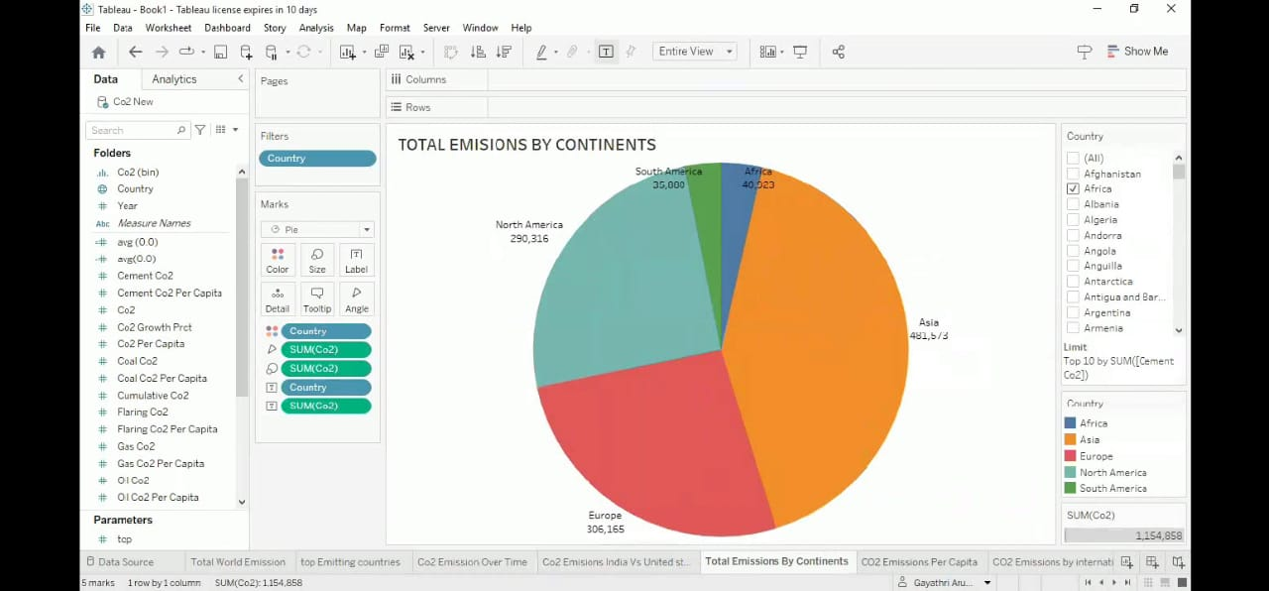

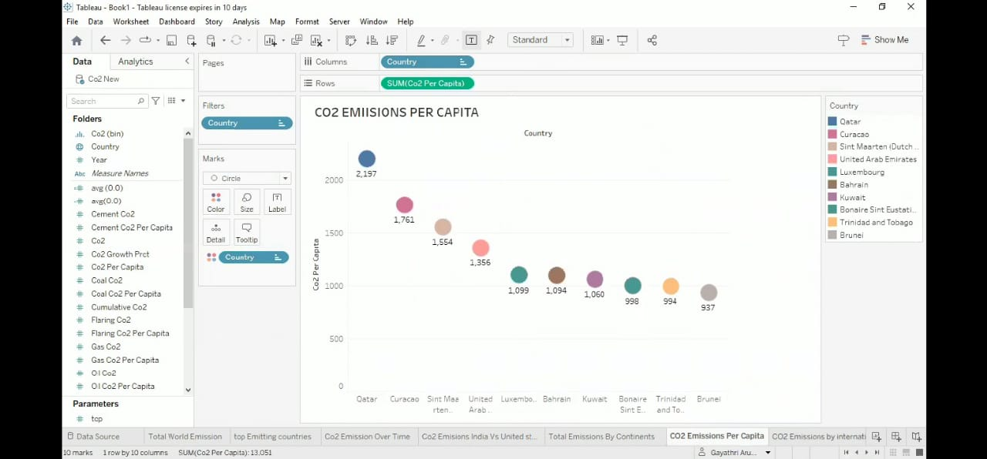

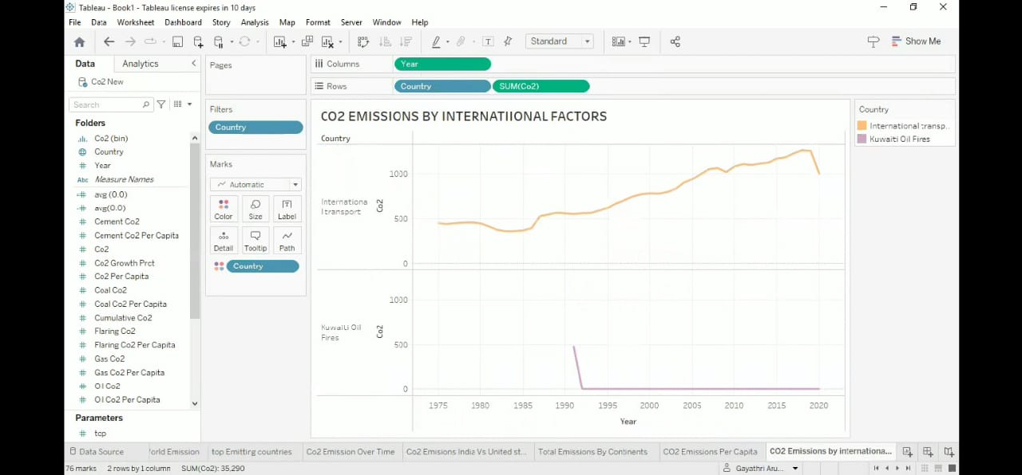

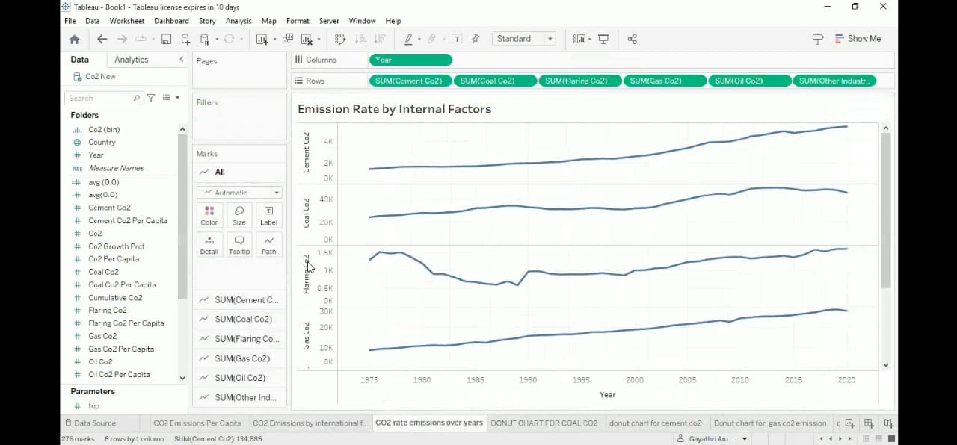

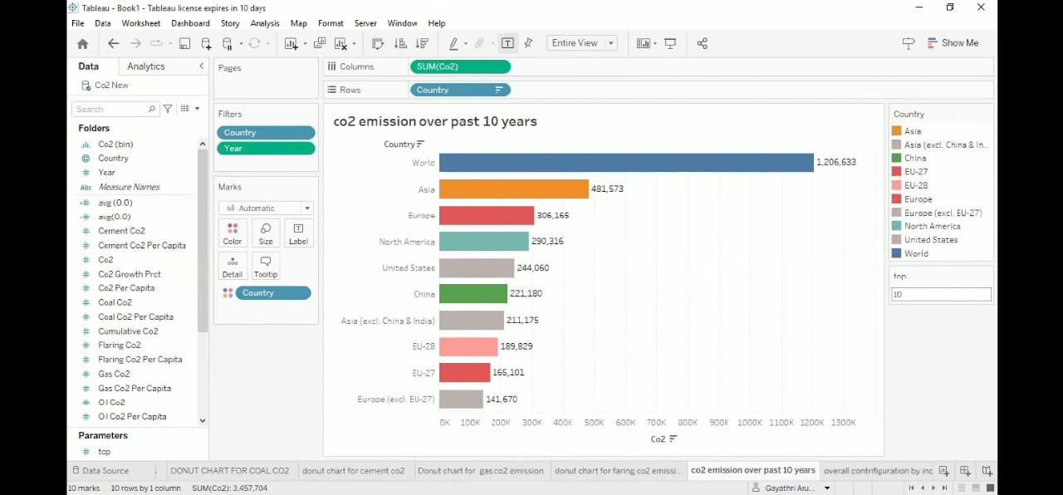

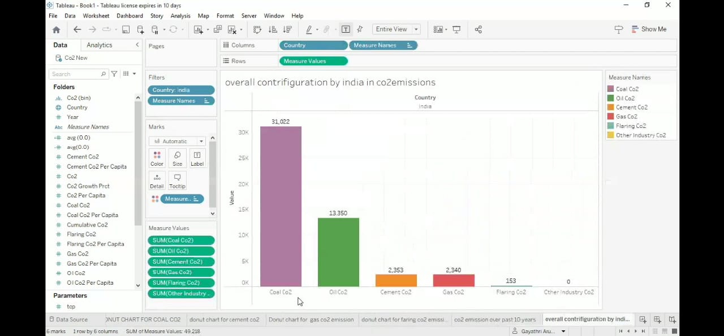

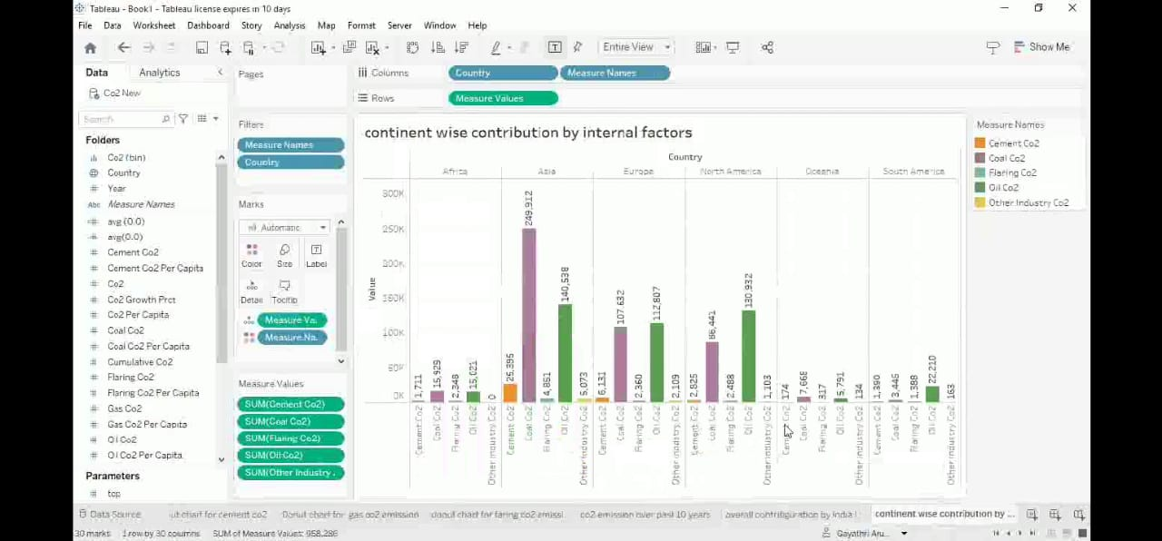

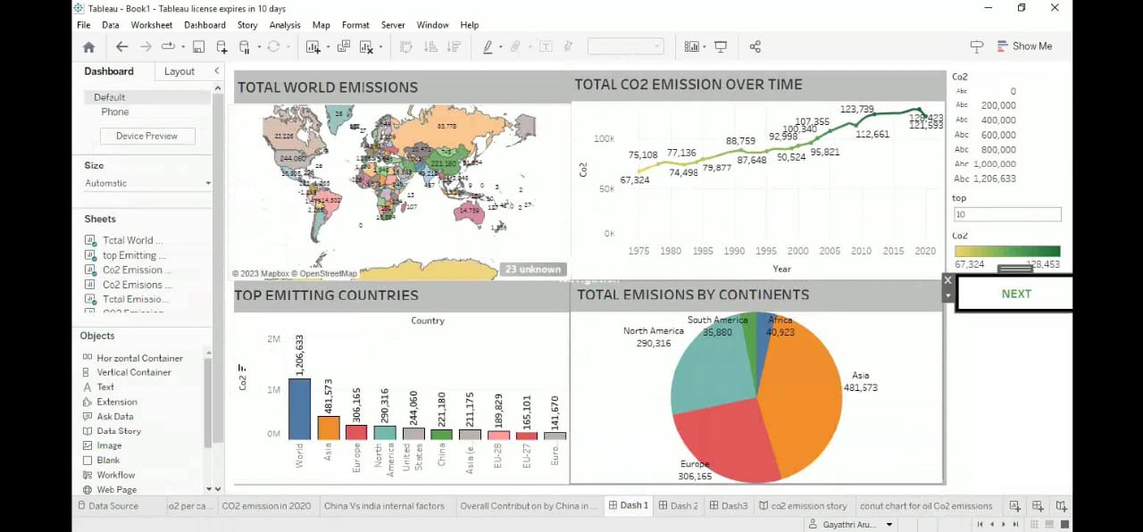

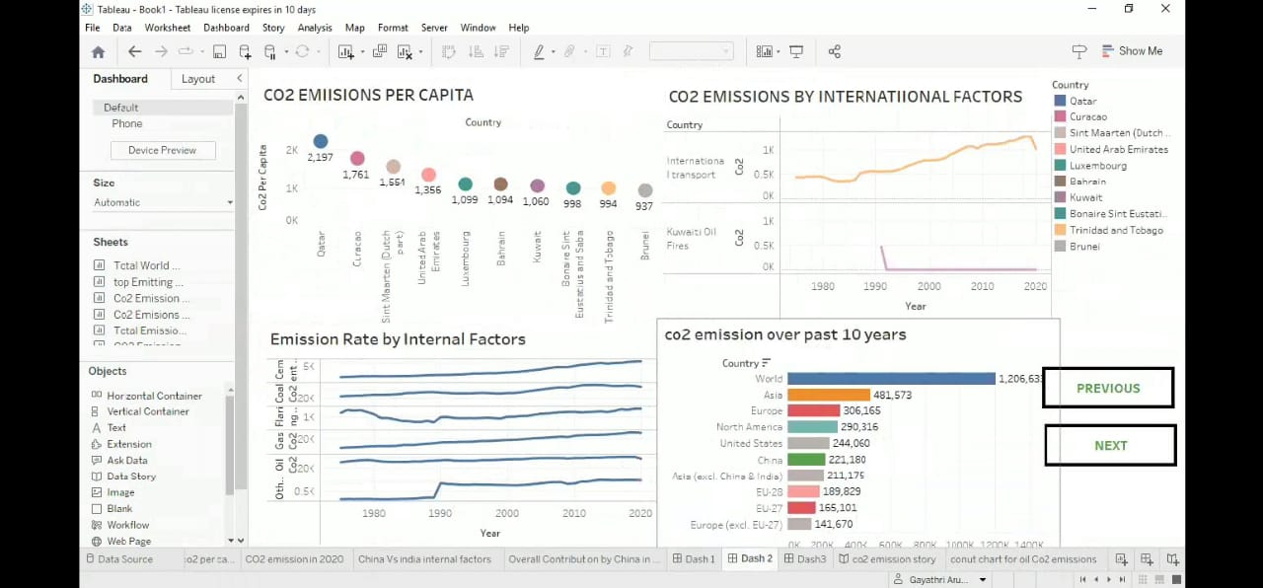

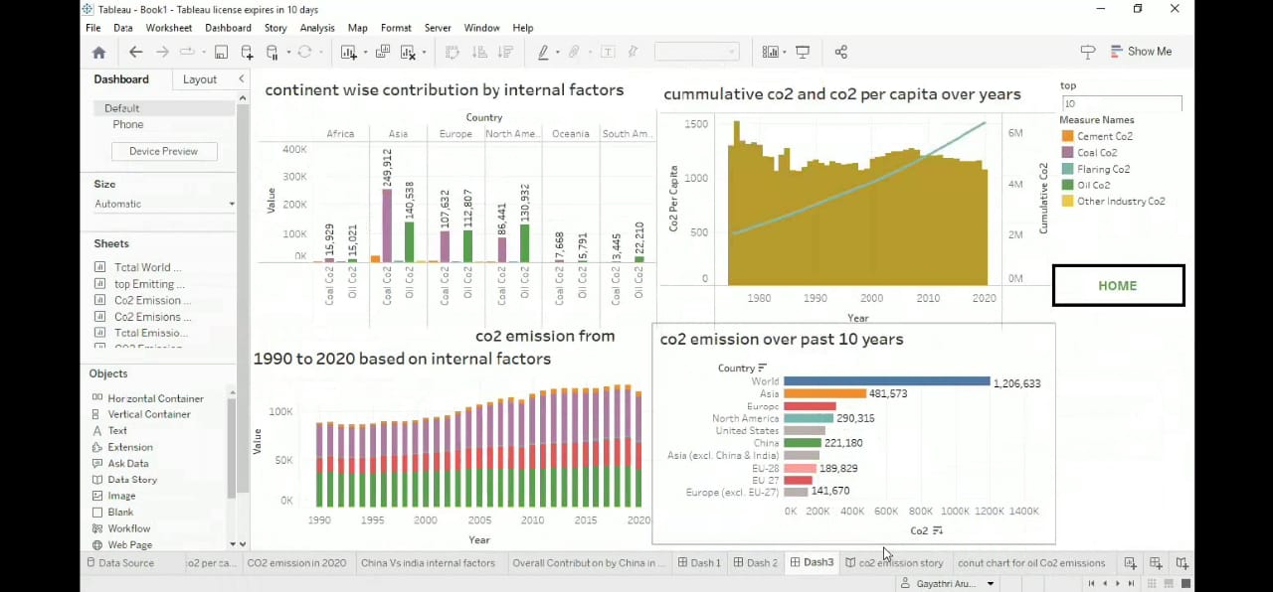

*CO2 EMISSION STORY

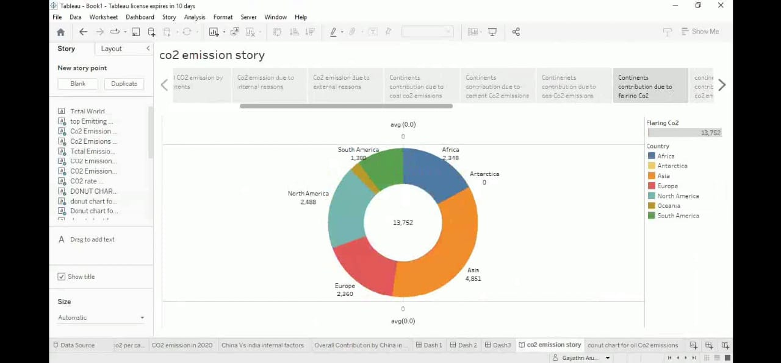

**4. ADVANTAGES**

Pure CO2 gas is chemically inert, transparent, colorless, and odorless. On a cold winter day, chilled air often condenses the water vapor of human breath—of which 4 to 5 percent is CO2—into visible fog. Such fog, however, is not CO2. Similarly, water vapor often condenses into clouds of steam over fossil-fuel power plants, creating the impression of smoke.

Such steam clouds are not CO2, either. Of every million air molecules in today’s atmosphere, 400 are CO2. This average masks wide variation. For example, without strong ventilation, CO2 levels in crowded indoor spaces, such as classrooms, courtrooms, and trains, commonly reach 2,000 ppm—with no clinically documented ill effects to people. The U.S Navy strives to keep CO2 levels in its submarines below 5,000 ppm.9On a calm summer day, CO2 concentrations in a cornfield can drop to 200 ppm, as the growing corn consumes the available CO2.

At a concentration of about 150 ppm or less, many plants die of CO2 starvation.11 The differences between the peak winter CO2 levels and minimum summer CO2 levels, measured at Hawaii’s MaunLoa volcano , have increased over the past 50years. This is believed to be due a global expansion of forests and other plant life.That Earth has experienced a CO2 “famine” for millions of years is also not widely known. As illustrated in Figure 5, in the 550 million years since the Cambrian period—when abundant fossils first appeared in the sedimentary record—CO2 levels have averaged many thousands of ppm, that is, much larger than the CO2 level of 400 ppm today.

All animals, including humans, owe their existence to green plants that use energy from sunlight to convert CO2 and water molecules into carbohydrates, releasing oxygen into the atmosphere in the process.

**5.DISADVANTAGES**

* Carbon dioxide is an important greenhouse gas that helps to trap heat in our atmosphere. Without it, our planet would be inhospitably cold. However, an increase in CO2 concentrations in our atmosphere is causing average global temperatures to rise, disrupting other aspects of Earth's climate,
* That's why the amount of carbon in the atmosphere has become so bad. These emissions into the atmosphere disrupt the dynamics of natural warming on Earth.
* **Carbon's problems**
  + - * melting glaciers;
      * floods and drought
      * loss of biodiversity;
      * volcanoes erupting, etc
* Exposure to CO2 can produce a variety of health effects. These may include headaches, dizziness, restlessness, a tingling or pins or needles feeling, difficulty breathing, sweating, tiredness, increased heart rate, elevated blood pressure, coma, asphyxia, and convulsions

6.PURPOSE

The carbon in CO2 can be used to produce fuels that are in use today, including methane, methanol, gasoline and aviation fuels.

Carbon dioxide is used as a refrigerant, in fire extinguishers, for inflating life rafts and life jackets, blasting coal, foaming rubber and plastics, promoting the growth of plants in greenhouses, immobilizing animals before slaughter, and in carbonated beverages.

Globally, some 230 million tonnes (Mt) of carbon dioxide (CO2) are used every year. The largest consumer is the fertiliser industry, where 130 Mt CO2 is used in urea manufacturing, followed by oil and gas, with a consumption of 70 to 80 Mt CO2 for enhanced oil recovery.

7.APPLICATIONS

* The carbon (and oxygen) in CO2 can be used as an alternative to fossil fuels in the production of chemicals, including plastics, fibres and synthetic rubber. As with CO2-derived fuels, converting CO2 to methanol and methane is the most technologically mature pathway.
* carbon dioxide is dissolved in water at high pressure to make soda water and other soft drinks.
* Food grains can be stored in an atmosphere of carbon dioxide to protect them from insects.
* Carbon dioxide is used in the manufacture of washing soda, baking soda, and also in the manufacture of fertilizers.
* Carbon dioxide does not support combustion, hence it is used in fire extinguishers.

8. CONCLUSION

The rising level of atmospheric CO2 could be the one global natural resource that is progressively increasing food production and total biological output, in a world of otherwise diminishing natural resources of land, water, energy, minerals, and fertilize.

9.APPENDIX

<https://drive.google.com/file/d/1PPuMNYbgL0t_2VngfxcrNihRBgvVpA5X/view?usp=drivesdk>